Week 7: Data Storage and Database Integration in Mobile Applications
Student Name: Precious Jaiyesimi Eniola
Admission number: BIT/2024/39050
Course: Mobile Application Development
School/Faculty: Computing and Informatics, Mount Kenya University_
Program: Information Technology
Academic Year: 4th
Semester: First
Lecturer: Mr Nyoro

Task Completed
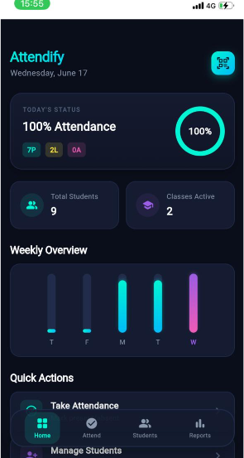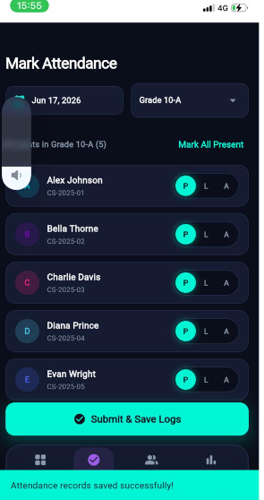
Home screen Attendance Screen

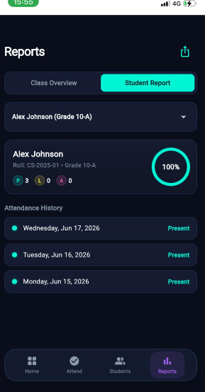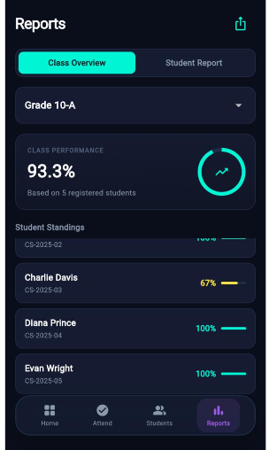
Report screens
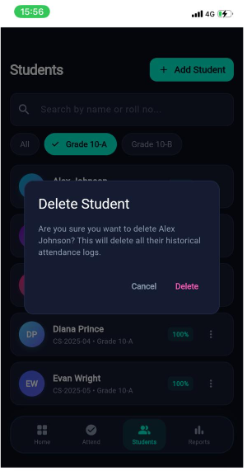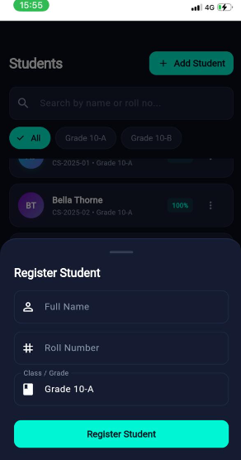
Add and delete student screens

Tools/Software Used
- Flutter
- Dart (
- VS Code (code editor)
- sqflite (Flutter package for SQLite integration)

Personal Reflection

This project helped me understand how a complete mobile application is built from scratch, starting from setup, UI design, database creation, and functionality implementation. At the beginning, I found it challenging to connect different parts of the system such as the database, screens, and navigation. However, through step-by-step development, I learned how Flutter uses widgets to build interfaces and how Dart handles logic behind the scenes.

